**ASSIGNMENT 1.WEEK TWO**

1. INSTALLATION OF VISUAL STUDIO CODE.

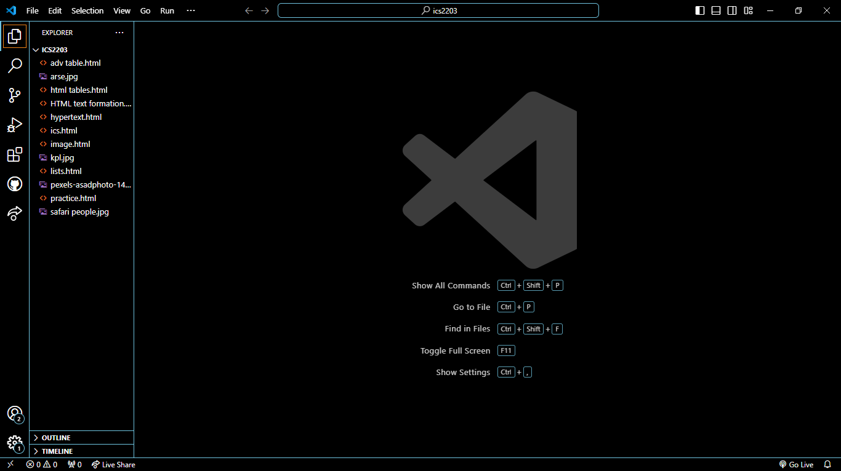

2. INSTALLATION OF GIT

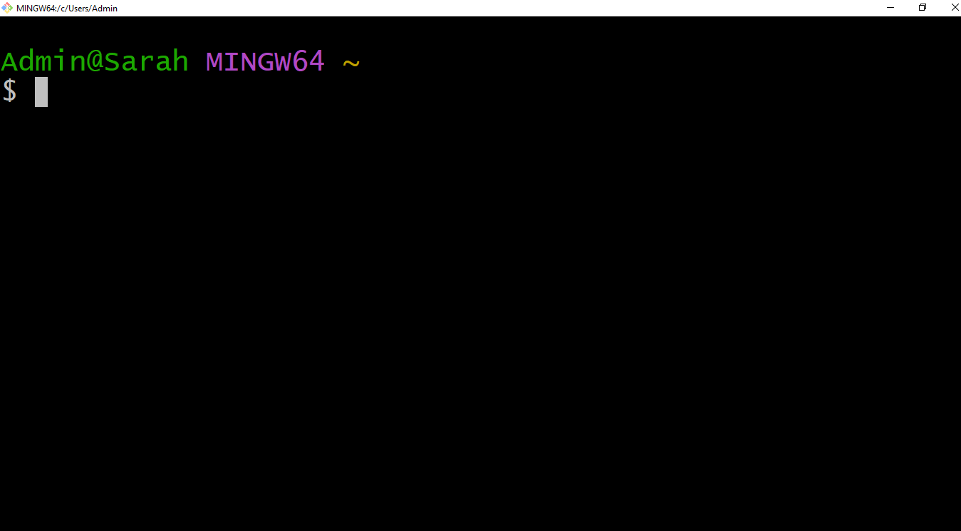

3. GIT HUB ACCOUNT.

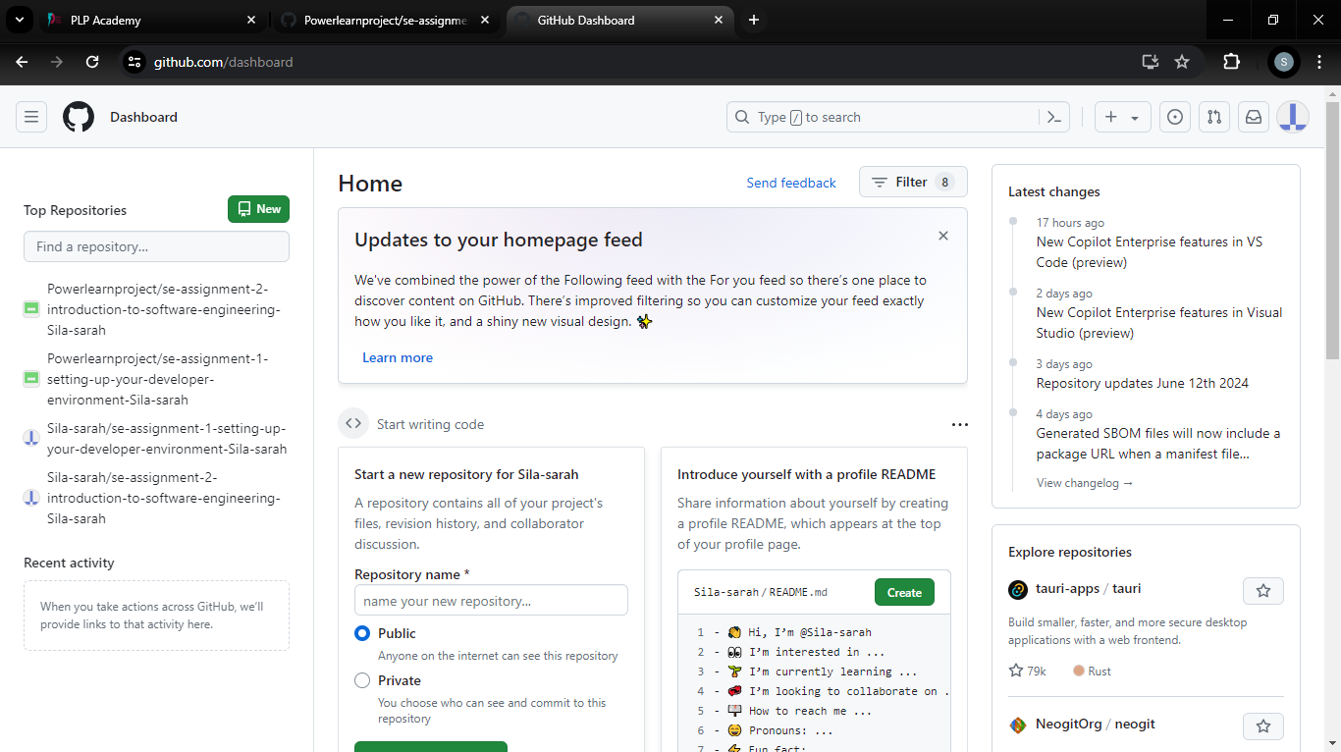

4.MY SQL

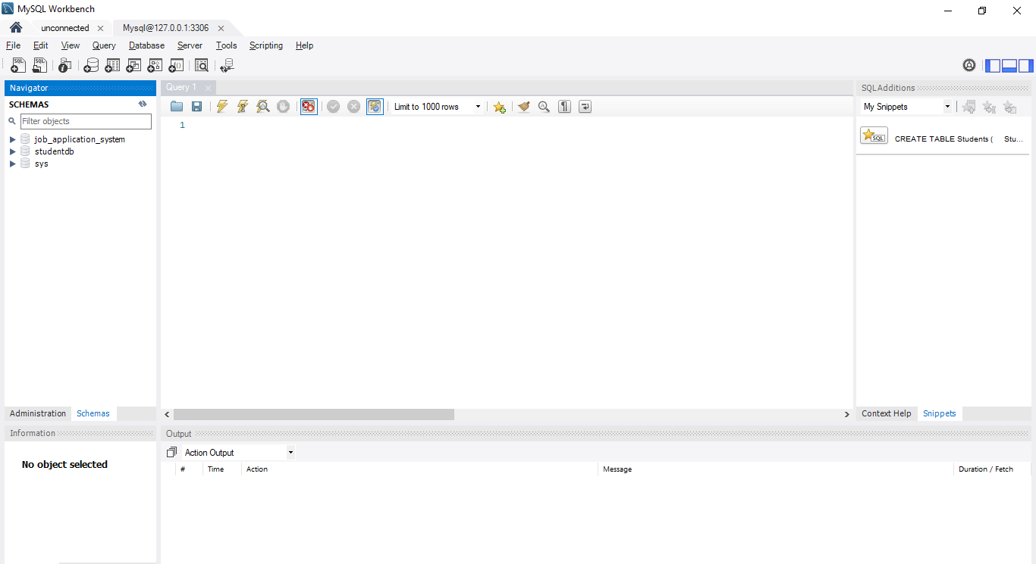

5.EXTENSIONS ;

(a) python

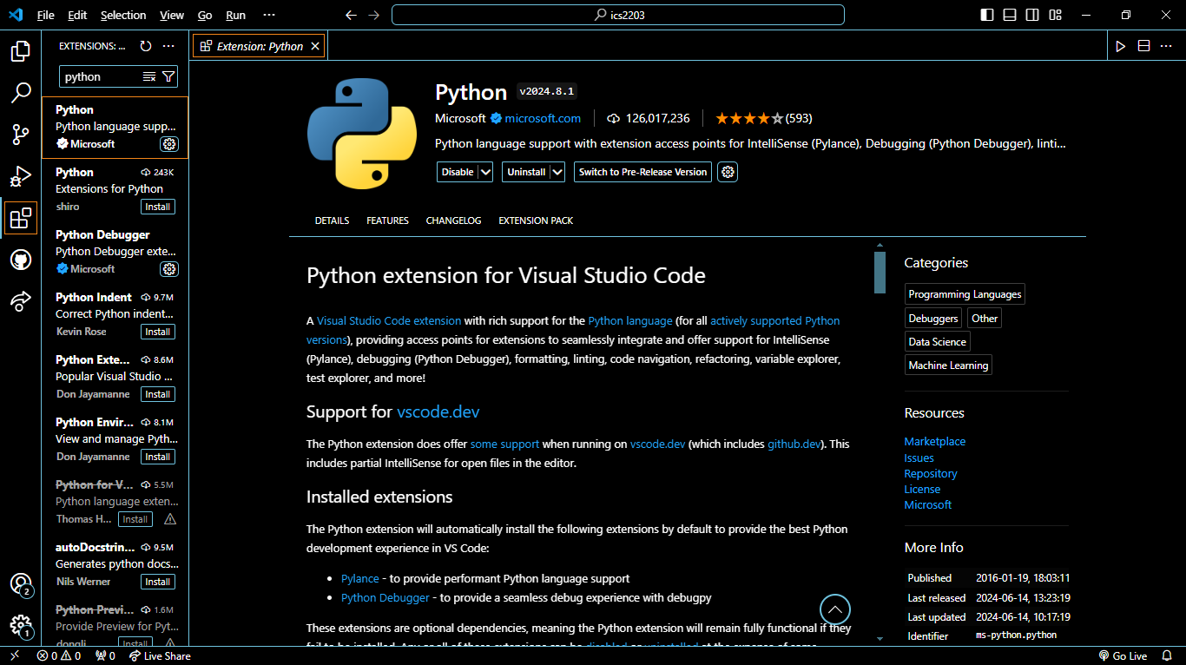

(b) git bash

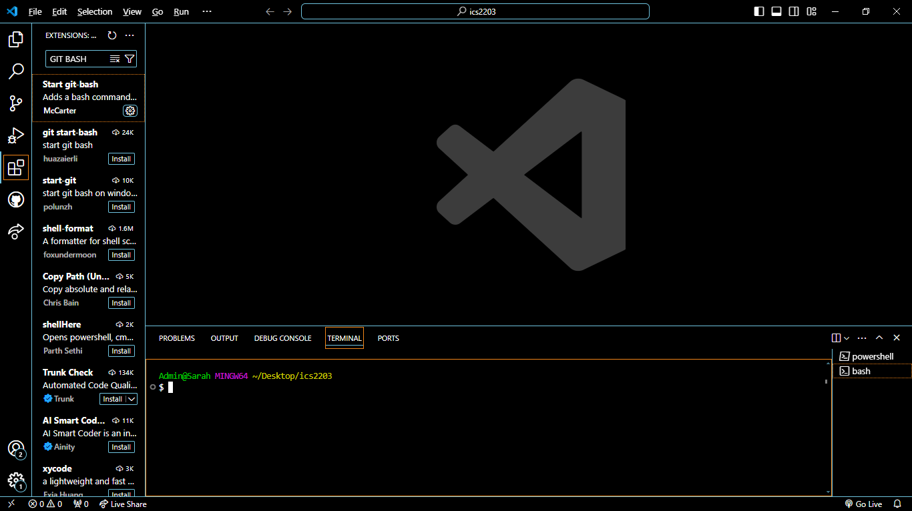

© power shell

